**University of Passau**

**School of Business, Economics and Information Systems**

**Instructions for completing the Credit Transfer Application Form   
for coursework completed at other higher education institutions**

Instructions:

* Complete the application in **Word** format. The supporting documents (module descriptions, transcripts, and translations, if required) should be in **PDF format**. Please send all files to the programme coordinators ([studiengangskoordination.wiwi@uni-passau.de](mailto:studiengangskoordination.wiwi@uni-passau.de)) by e-mail.
* Fill in the application **digitally** and not by hand.
* Pay particular attention to **all** fields marked **yellow** in the sample application (see below).
* Please write the **exact, official module or course titles**.
* For acceptance for credit of **language courses/modules,**please contact Mr Killer at the Language Centre ([Wolfgang.Killer@uni-passau.de](mailto:Wolfgang.Killer@uni-passau.de)).
* For credit transfers to the ***Studium Generale*** module area (Bachelor BAE versions 2013 and 2014 or Bachelor WI version 2015 and 2023), please use [this application form](https://www.wiwi.uni-passau.de/fileadmin/dokumente/fakultaeten/wiwi/dekanat/Studiengangskoordination/LA_Antrag_Studium_Generale.pdf) and send it to [studiendekan.wiwi@uni-passau.de](mailto:studiendekan.wiwi@uni-passau.de)
* Please be aware that you will be moved up by one subject semester (“Fachsemester”) **for every 25 ECTS** **credits** gained through the credit transfer.
* If necessary, the mark you attained at the other higher education institution will be **converted** to the **marking system** of the University of Passau (1.0, 1.3, 1.7, 2.0, 2.3, 2.7, 3.0, etc.).

Answers to common questions:

* **Only one credit transfer for each module/course/assessment**: You cannot have the same academic work credited to more than one course/module at the University of Passau.
* Courses or modules can be accepted **regardless** of their ECTS credit load. For example, it is possible to have a 3-ECTS module credited as a 5-ECTS module. However, please be aware that a diverging ECTS credit load might be indicative of a difference in the module/course content delivered, which can potentially lead to your credit transfer application being rejected.
* It is possible to have **multiple** modules/courses (but not more than 3) credited towards **one single module** at Passau. In such cases, and upon approval by the professor, the **average mark** is calculated and used.
* If a course at your previous higher education institution had a credit load of 6 ECTS credits but the corresponding module at the University of Passau only has a 5-ECTS credit load, you will receive the 5 ECTS credits allocated for the module at the University of Passau.

Below are 2 screenshots of a sample application form on which the fields to be completed by the applicant are highlighted. The fields to be filled in on the first page are the fields for personal information and the fields for information on the studies at the University of Passau and the previous studies. 
On the second page, the course name at the old university and at the University of Passau as well as the examination number for each course must be added. Finally, the date and the name of the applicant must be added as a "signature".

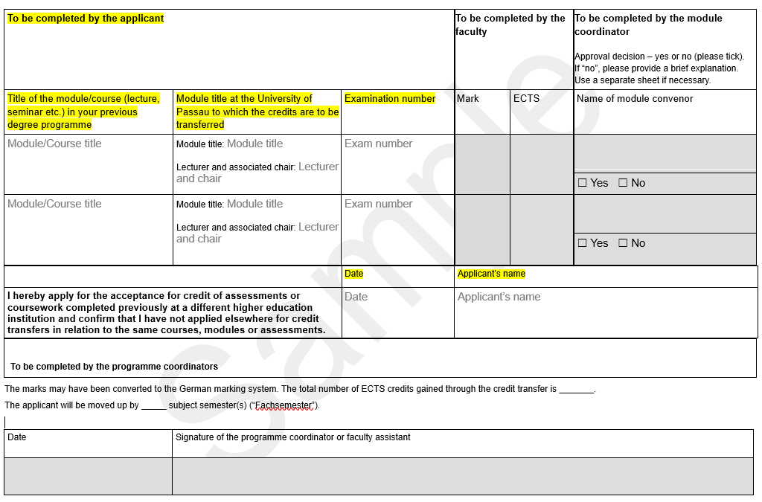

**University of Passau**

**School of Business, Economics and Information Systems**

# **Credit Transfer Application Form for coursework completed at other higher education institutions**

This application form is for coursework you completed **prior to** enrolment at the University of Passau. You must be currently enrolled at the University of Passau to apply for credit transfers.

Personal details:

|  |  |  |  |
| --- | --- | --- | --- |
| Family and given name(s) | Family name(s) and given name(s) | Phone number | Phone number |
| Address (street, house number, postcode, town) | Address | E-mail address | E-mail address |

Details on your degree programme at the University of Passau and your previous degree programme at the other higher education institution:

|  |  |  |  |
| --- | --- | --- | --- |
| Degree programme at the University of Passau (Bachelor’s/Master’s + programme title) | Current degree programme | Matriculation number at the University of Passau | Matriculation number |
| Previous degree programme (Bachelor’s/Master’s + programme title + university) | Previous degree programme | Enrolled at the University of Passau since...  (tick relevant box  and enter year) | winter semester Enter year  summer semester Enter year |

You must enclose the following documents:

EXA printout from the Campus Portal or certificate

Module descriptions of the courses at your previous higher education institution (provide a **separate** PDF for **each** description; **do** **not** submit the entire module catalogue)

Translations (only for documents not issued in German or English)

**NOTE:** Your application is only complete if you submit **the application form and** **all required documents**. Incomplete applications will not be processed and will be returned to you.

| To be completed by the applicant | | | To be completed by the faculty | | To be completed by the module coordinator  Approval decision – yes or no (please tick).  If “no”, please provide a brief explanation. Use a separate sheet if necessary. |
| --- | --- | --- | --- | --- | --- |
| Title of the module/course (lecture, seminar etc.) in your previous degree programme | Module title at the University of Passau to which the credits are to be transferred[1] | Examination number1 | Mark | ECTS | Name of module convenor |
| Module/Course title | Module title: Module title  Lecturer and associated chair: Lecturer and chair | Exam number |  |  |  |
| Yes  No |
| Module/Course title | Module title: Module title  Lecturer and associated chair: Lecturer and chair | Exam number |  |  |  |
| Yes  No |
| Module/Course title | Module title: Module title  Lecturer and associated chair: Lecturer and chair | Exam number |  |  |  |
| Yes  No |
| Module/Course title | Module title: Module title  Lecturer and associated chair: Lecturer and chair | Exam number |  |  |  |
| Yes  No |
| Module/Course title | Module title: Module title  Lecturer and associated chair: Lecturer and chair | Exam number |  |  |  |
| Yes  No |
| Module/Course title | Module title: Module title  Lecturer and associated chair: Lecturer and chair | Exam number |  |  |  |
| Yes  No |

|  |  |  |
| --- | --- | --- |
|  | Date | Applicant’s name |
| **I hereby apply for the acceptance for credit of assessments or coursework completed previously at a different higher education institution and confirm that I have not applied elsewhere for credit transfers in relation to the same courses, modules or assessments.** | Date | Applicant’s name |

|  |
| --- |
| **To be completed by the programme coordinators** |

The marks may have been converted to the German marking system. The total number of ECTS credits gained through the credit transfer is _______.

The applicant will be moved up by _____ subject semester(s) (“Fachsemester”).

|  |  |
| --- | --- |
| Date | Signature of the programme coordinator or faculty assistant |
|  |  |

1. You can find this information in the module catalogue (<https://www.uni-passau.de/en/study-and-examination-regulations>) and on the chairs’ webpages (<https://www.wiwi.uni-passau.de/en/chairs-and-teaching-units>). If you cannot identify a suitable module, please enter the module area/module group instead.